Paper Title

First Author Name
1st author's affiliation
1st line of Name of organization
2nd line of city, country
1st author's email address
Second Author Name
2nd author's affiliation
1st line of Name of organization
2nd line of city, country
2nd author’s E-mail address
Third Author Name
3rd author's affiliation
1st line of Name of organization
2nd line of city, country
3rd author’s E-mail address

Abstract: This electronic document is a “live” template. The various components of your paper [title, text, heads, etc.] are already defined on the style sheet, as illustrated by the portions given in this document. Do not use special characters, symbols, or math in your title or abstract. The authors must follow the instructions given in the document for the papers to be published. You can use this document as both an instruction set and as a template into which you can type your own text.

Keywords: component; formatting; style; styling; insert (Minimum 5 to 8 key words)

INTRODUCTION
We ask that authors follow some simple guidelines. This document is a template. An electronic copy can be downloaded from the journal website. For questions on paper guidelines, please contact the conference publications committee as indicated on the conference website. Information about final paper submission is available from the conference website

PAGE SIZE
All material on each page should fit within a rectangle of 18 x 23.5 cm (7" x 9.25"), centered on the page, beginning 2.54 cm (1") from the top of the page and ending with 2.54 cm (1") from the bottom. The right and left margins should be 1.9 cm (.75”). The text should be in two 8.45 cm (3.33") columns with a .83 cm (.33") gutter.

TYPESET TEXT

Normal or Body Text
Please use a 9-point Times Roman font, or other Roman font with serifs, as close as possible in appearance to Times Roman in which these guidelines have been set. The goal is to have a 9-point text, as you see here. Please use sans-serif or non-proportional fonts only for special purposes, such as distinguishing source code text. If Times Roman is not available, try the font named Computer Modern Roman. On a Macintosh, use the font named Times. Right margins should be justified, not ragged.

This paragraph is a repeat of 3.1
Please use a 9-point Times Roman font, or other Roman font with serifs, as close as possible in appearance to Times Roman in which these guidelines have been set. The goal is to have a 9-point text, as you see here. Please use sans-serif or non-proportional fonts only for special purposes, such as distinguishing source code text. If Times Roman is not available, try the font named Computer Modern Roman. On a Macintosh, use the font named Times. Right margins should be justified, not ragged.

This paragraph is a repeat of 3.1
Please use a 9-point Times Roman font, or other Roman font with serifs, as close as possible in appearance to Times Roman in which these guidelines have been set. The goal is to have a 9-point text, as you see here. Please use sans-serif or non-proportional fonts only for special purposes, such as distinguishing source code text. If Times Roman is not available, try the font named Computer Modern Roman. On a Macintosh, use the font named Times. Right margins should be justified, not ragged.

Title and Authors
The title (Helvetica 18-point bold), authors' names (Helvetica 12-point) and affiliations (Helvetica 10-point) run across the full width of the page – one column wide. We also recommend e-mail address (Helvetica 12-point). See the top of this page for three addresses. If only one address is needed, center all address text. For two addresses, use two centered tabs, and so on. For three authors, you may have to improvise.

Subsequent Pages
For pages other than the first page, start at the top of the page, and continue in double-column format. The two columns on the last page should be as close to equal length as possible.

Table 1. Table captions should be placed above the table
Graphics | Top | In-between | Bottom
Tables | End | Last | First
Figures | Good | Similar | Very well

Page Numbering, Headers and Footers
Do not include headers, footers or page numbers in your submission. These will be added when the publications are assembled.

FIGURES/CAPTIONS
Place Tables/Figures/Images in text as close to the reference as possible (see Figure 1). It may extend across both columns to a maximum width of 17.78 cm (7”).
Captions should be Times New Roman 9-point bold. They should be numbered (e.g., “Table 1” or “Figure 2”), please note that the word for Table and Figure are spelled out. Figure’s captions should be centered beneath the image or picture, and Table captions should be centered above the table body.

SECTIONS
The heading of a section should be in Times New Roman 12-point bold in all-capitals flush left with an additional 6-points of white space above the section head. Sections and subsequent sub- sections should be numbered and flush left. For a section head and a subsection head together (such as Section 3 and subsection 3.1), use no additional space above the subsection head.
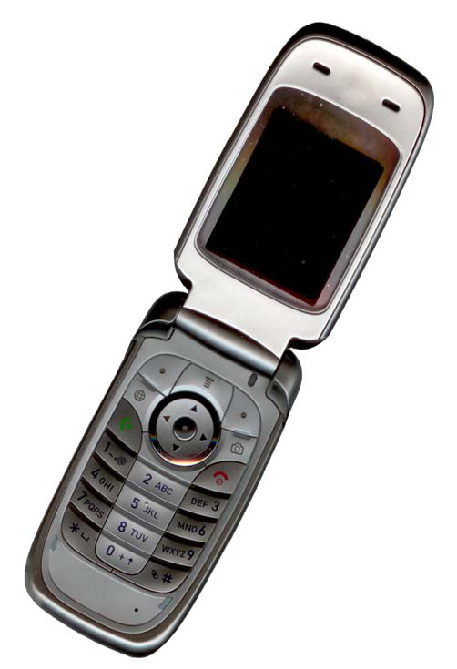
Figure. 1 Example of an image with acceptable resolution

Subsections
The heading of subsections should be in Times New Roman 12-point bold with only the initial letters capitalized. (Note: For subsections and subsubsections, a word like the or a is not capitalized unless it is the first word of the header.)

Subsubsections
The heading for subsubsections should be in Times New Roman 11-point italic with initial letters capitalized and 6-points of white space above the subsubsection head.

Subsubsections
The heading for subsubsections should be in Times New Roman 11-point italic with initial letters capitalized.

Subsubsections
The heading for subsubsections should be in Times New Roman 11-point italic with initial letters capitalized.

Subsubsections
The heading for subsubsections should be in Times New Roman 11-point italic with initial letters capitalized.

Subsubsections
The heading for subsubsections should be in Times New Roman 11-point italic with initial letters capitalized.

Subsubsections
The heading for subsubsections should be in Times New Roman 11-point italic with initial letters capitalized.

Subsubsections
The heading for subsubsections should be in Times New Roman 11-point italic with initial letters capitalized.

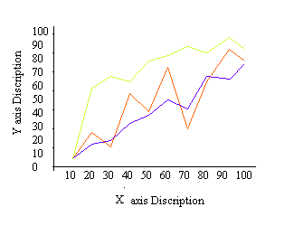
Figure 2. Example of a One-Column figure caption.

ACKNOWLEDGMENTS
Our thanks to the experts who have contributed towards development of the template.

REFERENCES
- Bowman, M., Debray, S. K., and Peterson, L. L. 1993. Reasoning about naming systems. .
- Ding, W. and Marchionini, G. 1997 A Study on Video Browsing Strategies. Technical Report. University of Maryland at College Park.
- Fröhlich, B. and Plate, J. 2000. The cubic mouse: a new device for three-dimensional input. In Proceedings of the SIGCHI Conference on Human Factors in Computing Systems
- Tavel, P. 2007 Modeling and Simulation Design. AK Peters Ltd.
- Sannella, M. J. 1994 Constraint Satisfaction and Debugging for Interactive User Interfaces. Doctoral Thesis. UMI Order Number: UMI Order No. GAX95-09398., University of Washington.
- Forman, G. 2003. An extensive empirical study of feature selection metrics for text classification. J. Mach. Learn. Res. 3 (Mar. 2003), 1289-1305.
- Brown, L. D., Hua, H., and Gao, C. 2003. A widget framework for augmented interaction in SCAPE.
- Y.T. Yu, M.F. Lau, "A comparison of MC/DC, MUMCUT and several other coverage criteria for logical decisions", Journal of Systems and Software, 2005, in press.
- Spector, A. Z. 1989. Achieving application requirements. In Distributed Systems, S. Mullender

